Nose Gear:
Topology Structural Test & Optimization
Material Properties
Property | Value | Units
Young Modulus (E) | 4.2e9 | Pa
Poisson’s Ratio | 0.36 | -
Density | 1080 | kg/m^3
Yield Strength | 38 | MPa
Ultimate (UTS) | 47.8 | MPa
From: https://juggerbot3d.com/pla-filament-review/#:~:text=Polylactic%20Acid%20(PLA)%20is%20a%20recyclable%2C%20natural,D%2066%20*%20**Density**%201.08%20%2D%201.12g/cc

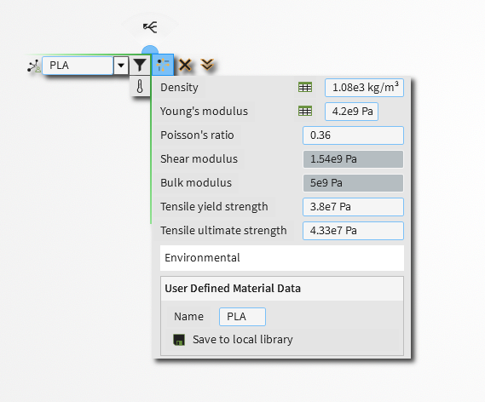

Boundary Conditions
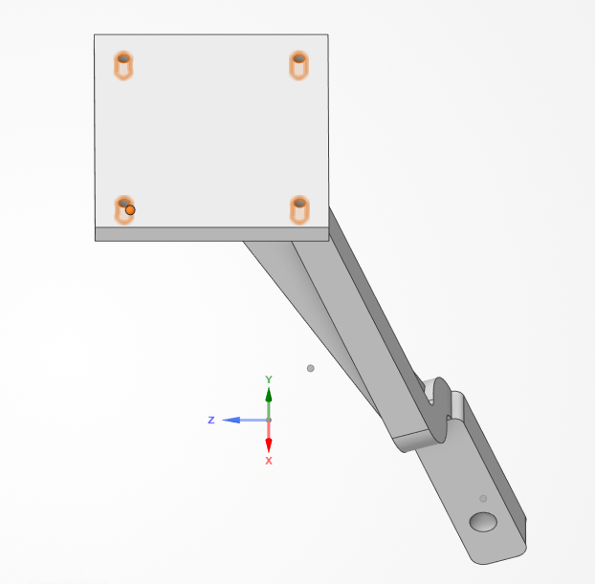 | 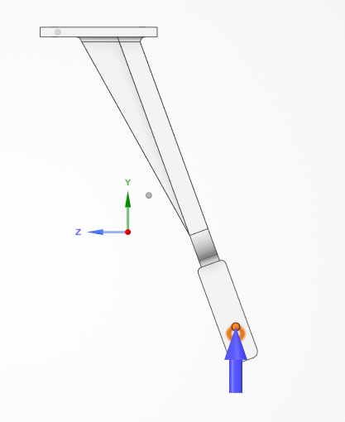
Fixed Supports: Bolts to Fuselage | Force: Components (X, Y, Z) at Wheel
Mesh Convergence
V1: Vertical – Static Parked
-XXX: Percentage of Fidelity in “Explore”, e.g., -050 = 50%
-XXXR: Percentage of Fidelity in “Refine” with Local Refinement; 1 mm and 0.5 mm
-XXXR2: Percentage of Fidelity in “Refine” with Local Refinement; 0.5 mm and 0.25 mm
-XXXR2F: Percentage of Fidelity in “Refine” with Local Refinement; 0.5 mm and 0.25 mm and 0.2mm filet in holes for stress singularity

Case | Description | Force (N) | Max Principal Stress (Pa) | Variation (%)
V1-050 | Static Parked | 4.81 | 1.89e6 | -
V1-058 | - | - | 2e6
V1-066 | - | - | 1.84e6
V1-075 | - | - | 1.76e6
V1-083 | - | - | 2.08e6
V1-091 | - | - | 1.93e6
V1-100 | - | - | 2.06e6
V1-050R | - | - | 4.2e6
V1-075R | - | - | 3.47e6
V1-100R | - | - | 3.95e6
V1-100R2 |  |  | 5.86e6

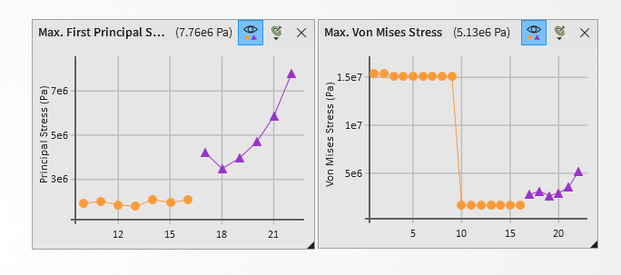
Von Misses Stresses criterion was selected for failure evaluation because: PLA is not purely brittle – 25.7% elongation. VMS valid for ductile/semi-ductile materials such as PLA. Numerical stability is demonstrated in VMS (ignore last data point due to radius addition), whereas principal stress is heavily reliant of mesh due to singularity issues. Additionally, VMS is conservative is this case (worse case).

Final Mesh: 100% Fidelity in “Refine” with local refinement of 0.5 mm in B-TH and 0.25 in T-TH. Number of Elements: 78706. Number of Nodes: 123572. Element Type: Quadratic Tet (Tend to underestimate in displacement but not much compared to Linear Tet).
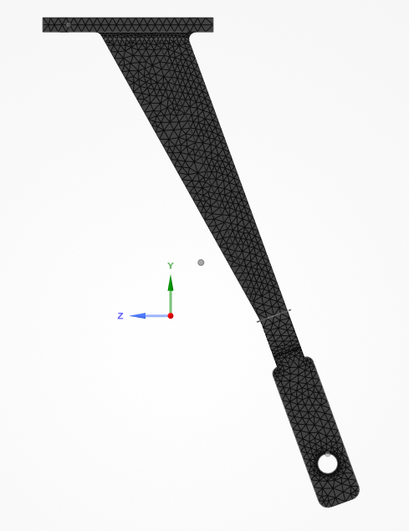 | 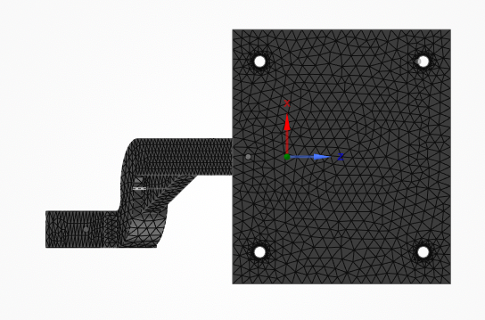
Final Mesh: Side View | Top View
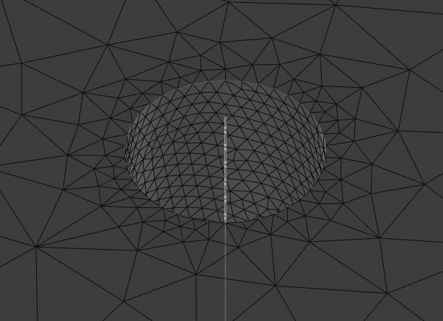 | 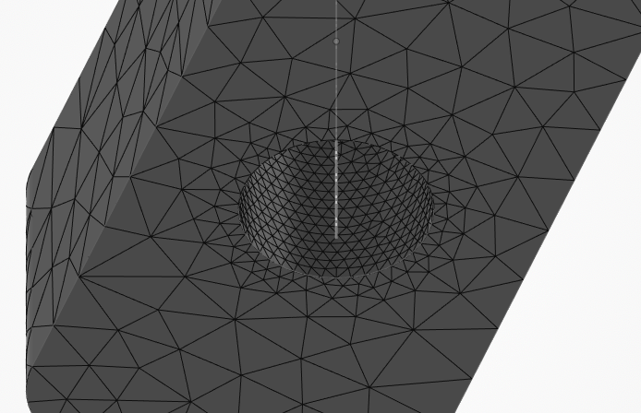
Local Sizing in T-TH | Local Sizing in B-TH

Test Matrix
Mass of the BUSR V3: 4.9kg
Vertical (+Y):
Case | Description | Nose % | g (m/s^2) | Force (N)
V1 | Static Parked | 10 | 1 | 4.81
V2 | Normal Landing (Main Gear 1st) | 10 | 3 | 14.42
V3 | Hard Landing | 15 | 5 | 36.05
V4 | Nose-first Landing | 50 | 5 | 120.17
V5 | Nose strike / crash | 50 | 10 | 240.35

Lateral and Axial (X, Z):
Gust (X) | Grass Drag (X, Z) | Stuck in Mud (Z)
A = 1.5 m × 0.12 m = 0.18 m²  F = 0.5 × 1.225 × (3)² × 1.3 × 0.18  F ≈ 1.3 N | a = 2 / 1 = 2 m/s²  F = 4.9 × 2 = 9.2 N | a = 3 / 0.3 = 10 m/s² F = 5 × 10 = 49 N

Case | Description | Force (N)
L1 | Gust | ±1.3
L2, A2 | Grass Drag | ±9.2
L3, A3 | Stuck in Mud | ±49

Combined:
Case | Description | Vertical (N) | Lateral (N)
C1 | Normal Landing + Gust | 14.42 | ±1.3 (L)
C2 | Hard Landing + Grass Drag | 36.05 | ±9.2 (L)
C3 | Nose-first + Mud (Maybe too Extreme) | 120.17 | ±49 (A)

Results
Focusing primarily on Maximum (First) Principal Stress due to brittle fracture criterion, with a limit of < 38 MPa or 3.8e7 Pa. Secondly, sanity checks such as Location of maximum stress, Von Mises; if lower, confirms multiaxial stress state
Vertical (+Y):
Case | VMS (Pa) | Safety Factor | Location | Displacement (mm) | Pass?
V1 | 3.48e6 | 10.9 | T-TH | 0.439 | Yes
V2 | 1.04e7 | 3.64 | T-TH | 1.31 | Yes
V3 | 2.61e7 | 1.46 | T-TH | 3.29 | Yes
V4 | 8.7e7 | 0.437 | T-TH | 11 | Cooked
V5 | 1.74e8 | 0.219 | T-TH | 21.9 | Cooked

Lateral (X):
Case | VMS (Pa) | Safety Factor | Location | Displacement (mm) | Pass?
L1 | 2.24e6 | 17 | T-Arm | 0.563 | Yes
L2 | 1.59e7 | 2.4 | T-Arm | 3.99 | Yes
A2 | 1e7 | 3.79 | T-TH | 1.54 | Yes
L3 | 8.44e7 | 0.45 | T-Arm | 21.2 | Cooked
L3* | <2.6e7 | 1.46 | C (Bijoy) | - | Yes
A3 | 5.34e7 | 0.711 | T-TH | 8.2 | Cooked
A3* | <2.19e7 | 1.72 | C (Bijoy) | - | Yes

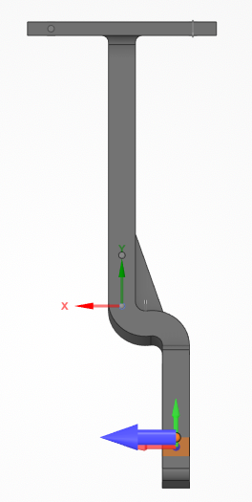 | 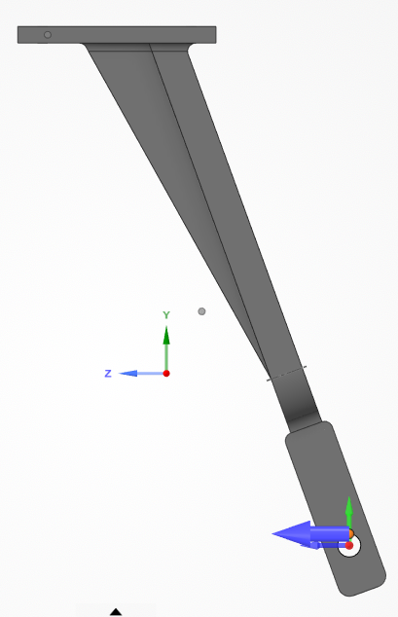
Front View: X component | Side View: Z component

Region of Flight test Failure (Bijoy):
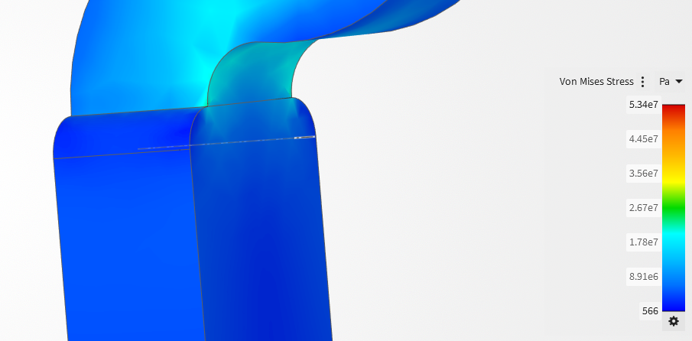
A3: Location of Failure @ Flight Test
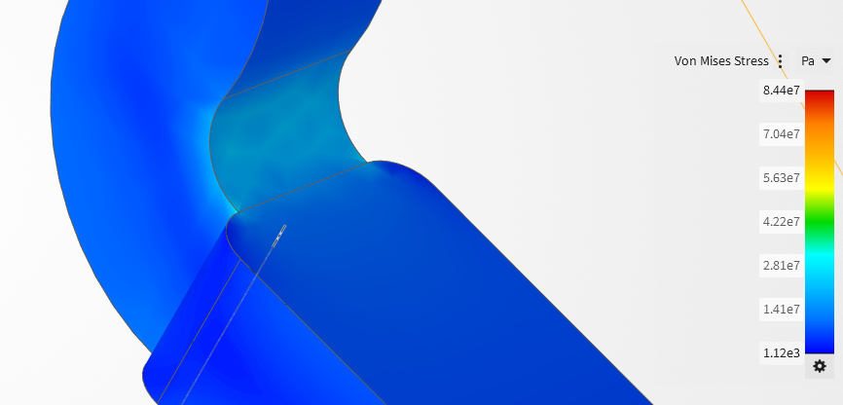
L3: Location of Failure @ Flight Test

Case | VMS (Pa) | Safety Factor | Location | Displacement (mm) | Pass?
C1 |  |  |  |  | Yes
C2 | 2.7e7 | 1.41 | T-TH, T-Arm | 2.85 | Yes
C3 | - | - | - | - | Cooked

